Binary Search Tree Delete

- Is this a binary search tree? Y/N How do you know?
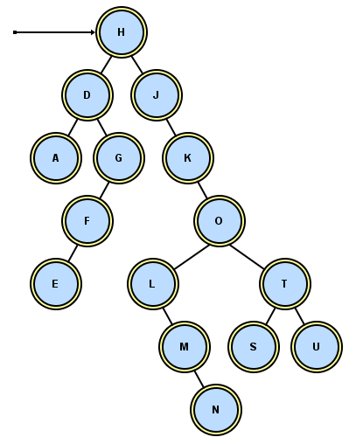

- When you delete a node, you have to preserve the BST order. Suppose you delete O. What letter(s) should go in its place? ______
How do you find that letter?

- Suppose you delete G. What letter(s) should go in its place?___
How do you find that letter?

- Suppose you delete D. What letter(s) should go in its place?___
How do you find that letter_

- Suppose you delete K. What letter(s) should go in its place?___
How do you find that letter?

- Suppose you delete U. What should go in its place?___
How do you find that letter?

- Suppose you delete S. What should go in its place?___
How do you find that letter?

- Suppose you delete the root, H. What should go in its place?___
Is deleting the root a special case or not?

- What case(s) have we missed?

- Describe and organize all the different cases:

Algorithm for Deleting a Node from a BST

Most people keep track of two pointers, a parent and a current.
Find the node to delete, updating parent and current as you go. Then identify which case:
(1) If the node is a leaf, just set its parent pointer to null.
(2) If the node has just one child (left or right), point the parent to current's child.
(3) If the node has two children, find the node containing the largest item in the node's left subtree and replace (use setValue) the node's object with the largest item. Then revert to case (1) or case (2), with the (just-found) largest item now being the current node.
Return the root.

Let's try it out. For each N in each tree, delete the N and re-draw the pointers:
For each N in each BST, delete it properly.

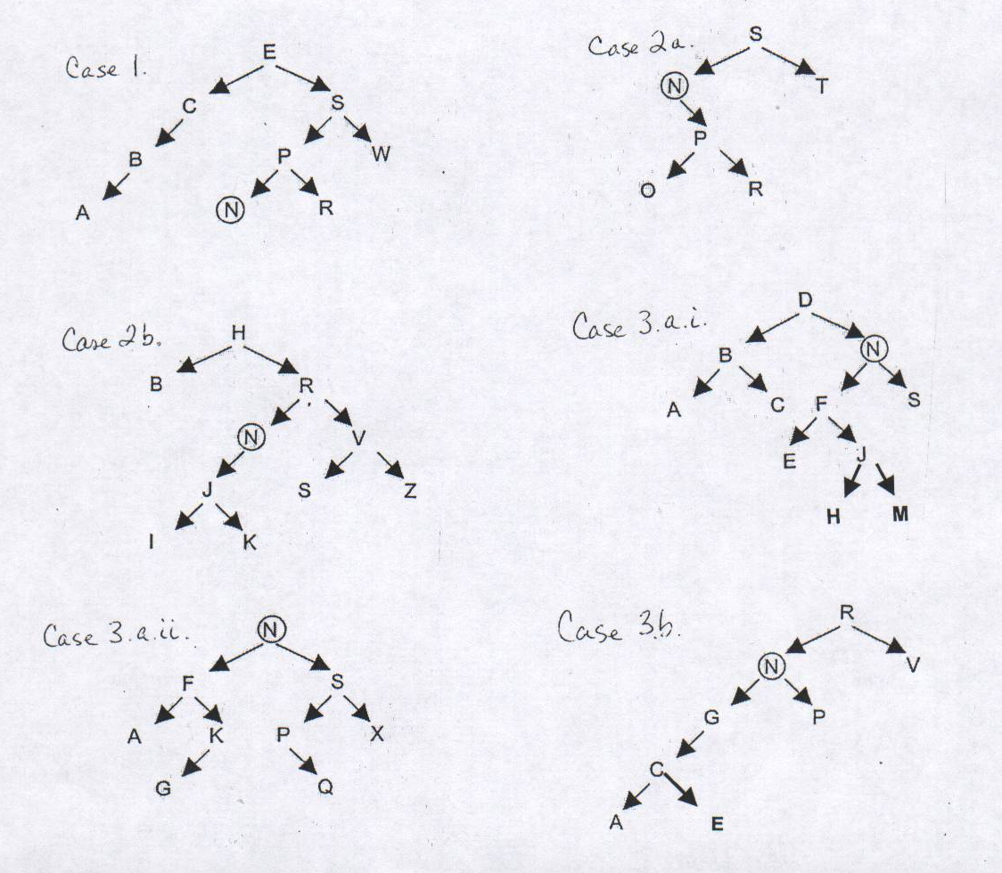
Let’s try it again:
Case 1: if target is a leaf . . .
Case 2 a: if target has one child to right . . .
b: if target has one child to left . . .
Case 3: target has two children.
a: if left child has a right, follow to bottom,
i. if it’s a leaf . . .
ii. if it has a left child . . .
b: if left child only has a left . . .

